Factors Affecting Mycelium Colonization Times

Theron Spencer

Spencet5@wwu.edu

MATH 343, 2019

**Introduction**

As most edible mushroom growers know, it’s important to be patient as it’s a hobby that can take many weeks to reap the rewards. Most of the time is spent on one growth stage in particular, the colonization stage. The following experiment has been conducted to see what factors affect the time for mycelium to fully colonize the substrate it’s growing in.

The model to assess the factors that affect colonization times is a 23 factorial design, where three factors, having two levels each, have been evaluated with n = 3 experimental units at each factor-level combination. The factors of interest are incubation temperature (room temperature vs 80F), vermiculite type (fine vs coarse), and water content (2:1:1.9 vs 2:1:2.1 ratios of brown rice flour, vermiculite, and water, respectively).

The mushroom species grown was Pleurotus ostreatus (Pearl Oyster Mushroom). A total of N = 24 four ounce jars were filled with a substrate consisting of brown rice flour, vermiculite, and water. Of those 24, half were filled at a ratio of 2:1:1.9 and the other half at a ratio of 2:1:2.1 of the ingredients, respectively. Of the 12 jars filled with the 2:1:1.9 ratio substrate, half were made using fine vermiculite and the other half using coarse vermiculite. Similarly for the jars filled with the 2:1:2.1 ratio substrate. To be as consistent as possible, the ratios are of mass, not volume since we’re using several dry ingredients. Each jar was inoculated with one milliliter of liquid culture. The liquid culture has live mycelium suspended in a sugar solution and was used to avoid the highly variable germination times associated with spore solutions. All jars were inoculated within 15 minutes and a timer began at 4:00pm on Sunday, May 19th. Then, with respect to testing every treatment combination, half were incubated at room temperature in a closet and the other half incubated in an incubator set at 80F. The jars were checked three times a day (every 8 hours or so as that worked best with my schedule) to assess colonization progress and final times were recorded, to the nearest 8 hour increment, after the mycelium had fully colonized the substrate.

The first jar to fully colonize took a little over 11 days and the last jar took about 16 days, bringing an end to data collection on June 4th. Overall, colonization went smoothly for every experimental unit, no contamination issues or growth stalling was encountered as sometimes happens in this hobby. The following is an analysis of the data.

**Analysis of Data**

The following are the colonization times for three jars tested at each treatment combination:

Factor A: Incubation Temp.; room temp. (-), 80F (+)

Factor B: Vermiculite type; fine (-), coarse (+)

Factor C: Substrate ratio; 2:1:1.9 (-), 2:1:2.1 (+)

Factor Time (hours)

|  |  |  |  |  |  |  |
| --- | --- | --- | --- | --- | --- | --- |
| A | B | C | Jar 1 | Jar 2 | Jar 3 | Mean |
| - | - | - | 360 | 360 | 368 | ${\overline{y}}_{(1)}$ = 362.67 |
| + | - | - | 288 | 280 | 288 | ${\overline{y}}_{a}$ = 285.33 |
| - | + | - | 336 | 344 | 352 | ${\overline{y}}_{b}$ = 344 |
| + | + | - | 280 | 264 | 272 | ${\overline{y}}_{ab}$ = 272 |
| - | - | + | 376 | 384 | 384 | ${\overline{y}}_{c}$ = 381.33 |
| + | - | + | 280 | 272 | 280 | ${\overline{y}}_{ac}$ = 277.33 |
| - | + | + | 392 | 384 | 376 | ${\overline{y}}_{bc}$ = 384 |
| + | + | + | 280 | 288 | 272 | ${\overline{y}}_{abc}$ = 280 |

The following are box plots of colonization times at each factor-level combination:

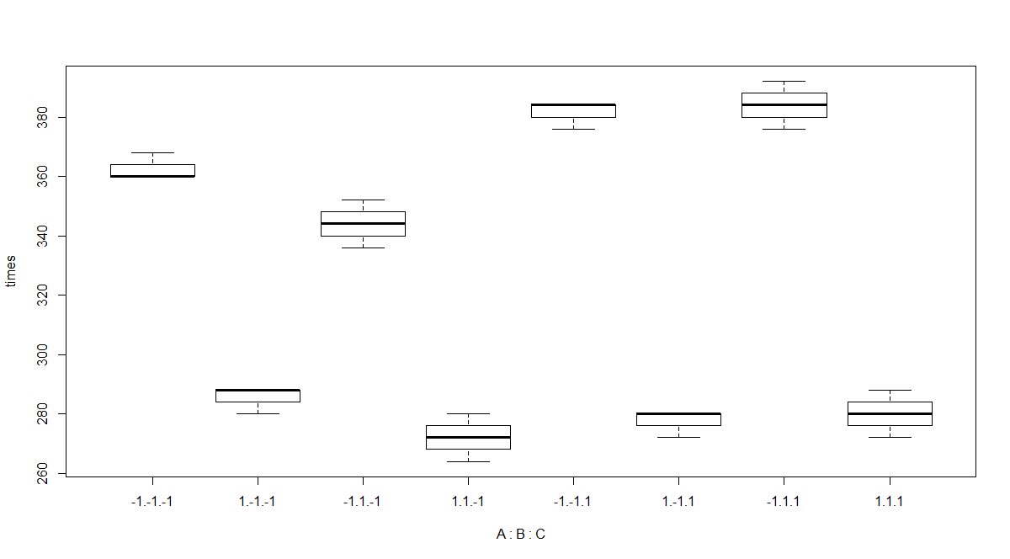

We can see there isn’t much variance within each factor-level combination, that is, each jar fully colonized within a short period (8-16 hours) of the other jars in the same factor-level combination.

The following is the ANOVA table for the full model:

Analysis of Variance Table

Response: times

Df Sum Sq Mean Sq F value Pr(>F)

A 1 47883 47883 1122.25 3.012e-16

B 1 267 267 6.25 0.023674

C 1 1291 1291 30.25 4.845e-05

A:B 1 11 11 0.25 0.623882

A:C 1 1291 1291 30.25 4.845e-05

B:C 1 523 523 12.25 0.002964

A:B:C 1 11 11 0.25 0.623882

Residuals 16 683 43

From the table above, we can conclude the main effects of A (incubation temp.), B (vermiculite type), C (water content), as well as the interactions effects AC and BC are significant at α = 0.05

After removing the insignificant effects, the following ANOVA table was produced for the reduced model:

Analysis of Variance Table

Response: times

Df Sum Sq Mean Sq F value Pr(>F)

A 1 47883 47883 1224.2727 < 2.2e-16

B 1 267 267 6.8182 0.017679

C 1 1291 1291 33.0000 1.91e-05

A:C 1 1291 1291 33.0000 1.91e-05

B:C 1 523 523 13.3636 0.001809

Residuals 18 704 39

Main effects calculations

$$A= \frac{{\overline{y}}_{abc}+{\overline{y}}_{ab}+{\overline{y}}_{ac}+{\overline{y}}_{a}}{4}-\frac{{\overline{y}}_{\left(1\right)}+{\overline{y}}_{b}+{\overline{y}}_{bc}+{\overline{y}}_{c}}{4}$$

$$=\frac{280+272+277.33+285.33}{4}-\frac{362.67+344+384+381.33}{4}=-89.33$$

$$B= \frac{{\overline{y}}_{abc}+{\overline{y}}_{ab}+{\overline{y}}_{bc}+{\overline{y}}_{b}}{4}-\frac{{\overline{y}}_{\left(1\right)}+{\overline{y}}_{a}+{\overline{y}}_{c}+{\overline{y}}_{ac}}{4}$$

$$=\frac{280+272+384+344}{4}-\frac{362.67+285.33+381.33+277.33}{4}=-6.66$$

$$C= \frac{{\overline{y}}_{abc}+{\overline{y}}_{ac}+{\overline{y}}_{bc}+{\overline{y}}_{c}}{4}-\frac{{\overline{y}}_{\left(1\right)}+{\overline{y}}_{a}+{\overline{y}}_{b}+{\overline{y}}_{ab}}{4}$$

$$=\frac{280+277.33+384+381.33}{4}-\frac{362.67+285.33+344+272}{4}=14.66$$

Interaction effects calculations

$$AC= \frac{{\overline{y}}_{abc}+{\overline{y}}_{ac}+{\overline{y}}_{b}+{\overline{y}}_{(1)}}{4}-\frac{{\overline{y}}_{a}+{\overline{y}}_{c}+{\overline{y}}_{ab}+{\overline{y}}_{bc}}{4}$$

$$=\frac{280+277.33+344+362.67}{4}-\frac{285.33+381.33+272+384}{4}=-14.66$$

$$BC= \frac{{\overline{y}}_{abc}+{\overline{y}}_{bc}+{\overline{y}}_{a}+{\overline{y}}_{(1)}}{4}-\frac{{\overline{y}}_{b}+{\overline{y}}_{c}+{\overline{y}}_{ab}+{\overline{y}}_{ac}}{4}$$

$$=\frac{280+384+285.33+362.67}{4}-\frac{344+381.33+272+277.33}{4}=9.33$$

95% Confidence intervals for effects

Here the CI’s were found using:

$$\hat{Effect}±t_{0.025, {df}_{error}}\sqrt{\frac{MSE}{n2^{k-2}}}=\hat{Effect}±t_{0.025, 18}\sqrt{\frac{39}{3*2}}=\hat{Effect}±5.356$$

Which yielded the following:

$$A: -89.33±5.356=\left(-94.686, -83.974\right)$$

$$B: -6.66±5.356=\left(-12.016, -1.304\right)$$

$$C: 14.66±5.356=\left(9.304, 20.016\right)$$

$$AC: -14.66±5.356=\left(-20.016, -9.304\right)$$

$$BC: 9.33±5.356=\left(3.974, 14.686\right)$$

Here, we can see A (incubation temps), by a large margin, clearly has the most effect on colonization times. Following after A, in decreasing order of magnitude of effect, is C (water content) and AC (temp and water content interaction) with the same magnitude, then BC (vermiculite type and water content interaction) and then lastly B (vermiculite type).

Evaluating interaction effects

Below are the interaction plots for AC (interaction term for incubation temp. and water content) and BC (interaction term for vermiculite type and water content):

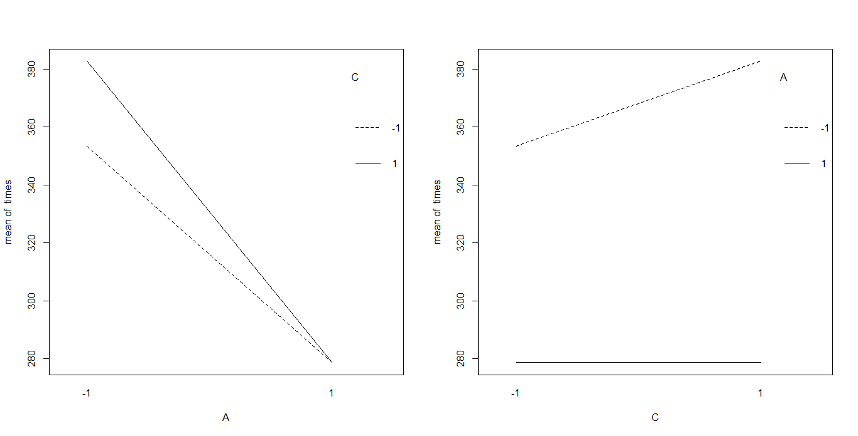

From the AC interaction plots, we can see water content doesn’t have an effect on mean colonization times when incubating at the high level. However, when incubating at the low level, the low level of water content is associated with the lower mean colonization times. Thus we can conclude from the plots, only with respect to the AC interaction, the lowest mean colonization times are achieved at high incubation temps, regardless of water content.

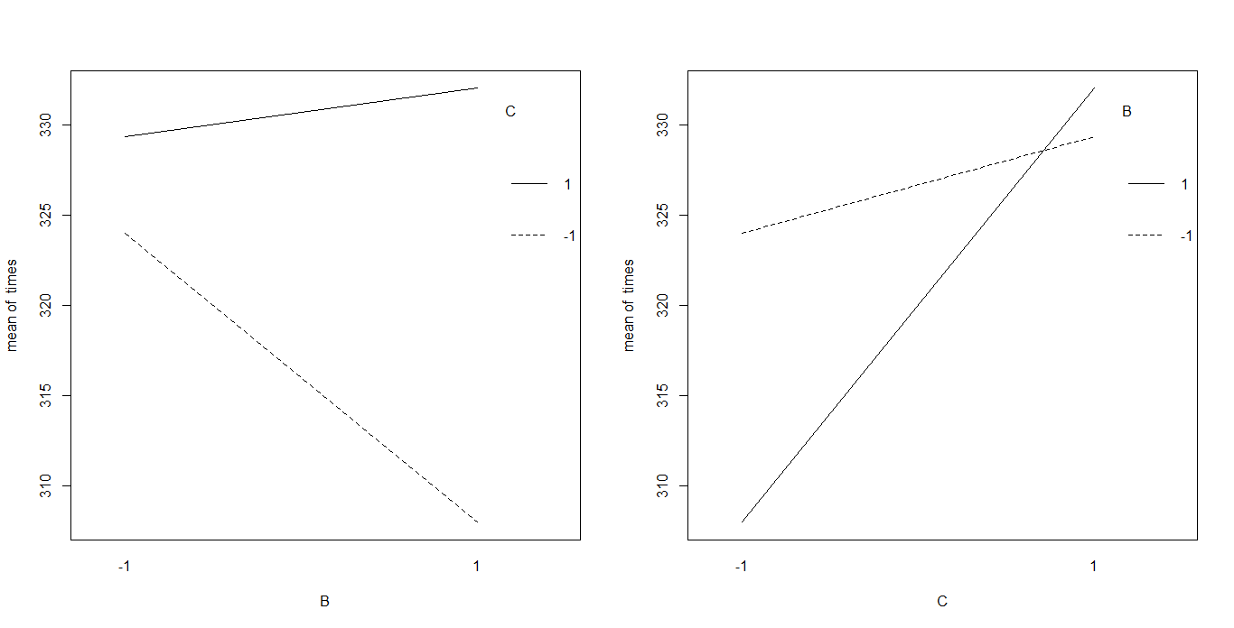

From the BC interaction plots, we can see if using the fine vermiculite (low level), the lower water content is associated with a lower mean colonization time. Similarly, and even more so, when using coarse vermiculite (high level), the lower water content is associated with a lower mean colonization time. Thus we can conclude from the plots, only with respect to the BC interaction, the lowest mean colonization times can be achieved using coarse vermiculite with the lower water content.

Expressing the results in terms of a regression

The following is the regression summary:

Call:

lm(formula = times ~ A + B + C + A * C + B * C)

Residuals:

Min 1Q Median 3Q Max

-9.3333 -5.3333 0.6667 2.6667 9.3333

Coefficients:

Estimate Std. Error t value Pr(>|t|)

(Intercept) 323.333 1.277 253.283 < 2e-16 ***

A -44.667 1.277 -34.990 < 2e-16 ***

B -3.333 1.277 -2.611 0.01768 *

C 7.333 1.277 5.745 1.91e-05 ***

A:C -7.333 1.277 -5.745 1.91e-05 ***

B:C 4.667 1.277 3.656 0.00181 **

---

Signif. codes: 0 ‘***’ 0.001 ‘**’ 0.01 ‘*’ 0.05 ‘.’ 0.1 ‘ ’ 1

Residual standard error: 6.254 on 18 degrees of freedom

Multiple R-squared: 0.9865, Adjusted R-squared: 0.9827

F-statistic: 262.1 on 5 and 18 DF, p-value: 3.728e-16

Which yields the following regression equation:

$$\hat{y}=323.33-44.67x_{A}-3.33x_{B}+7.33x_{C}-7.33x_{A}x_{C}+4.67x_{B}x_{C}$$

Where $x_{i}=\left\{\begin{aligned}-1, if factor is at the (-) level \\ 1, if factor is at the (+) level\end{aligned}\right.$, for *i* = A,B,C

As expected, the regression coefficients agree with our calculated effect estimates, that is, the regression coefficients are exactly half that of the estimated effects.

Suggested Factor-Level Combination

In order to minimize colonization times, as was our goal, the suggested factor level combination, made with respect to the interaction plots and effect’s magnitudes, is high level incubation temps (80F), high level vermiculite type (coarse), and low level water content (2:1:1.9). This was then confirmed by comparing the estimated mean colonization times yielded by the regression equation evaluated at every factor-level combination:

|  |  |  |  |  |
| --- | --- | --- | --- | --- |
| A | B | C | $$\hat{y}$$ | 95% CI for expected mean time |
| - | - | - | 361.34 |  |
| + | - | - | 286.66 |  |
| - | + | - | 345.34 |  |
| + | + | - | 270.66 | (260.87, 280.45)*See Appendix |
| - | - | + | 381.32 |  |
| + | - | + | 277.32 |  |
| - | + | + | 384 |  |

**Residual Analysis**

Below are two plots pertaining to the reduced model residuals:

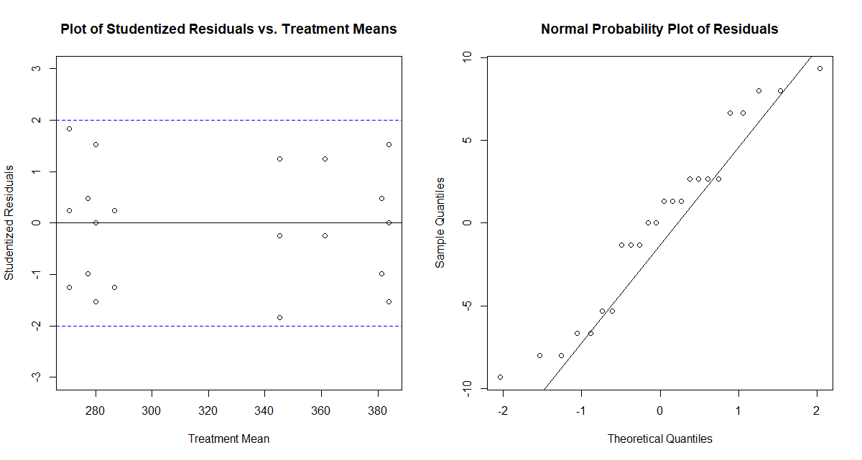

From the studentized residuals vs treatment means plot, we can see the residuals appear to be randomly scattered about 0, indicating the assumption of equality of variance has been met. Additionally, the normal probability plot of residuals appears to be linear, indicating they’re normally distributed. To confirm the normality assumption, the following test was ran:

Anderson-Darling normality test

data: model$residuals

A = 0.44793, p-value = 0.2559

From the Anderson-Darling test, a p-value of 0.2559 was yielded, thus we fail to reject the null hypothesis that the residuals are normally distributed, confirming our conclusion reached via visual inspection. Thus the model assumptions have been satisfied and no variable transformations are needed, leaving our prior analysis satisfactory in determining factor effects.

**Conclusion**

Overall, the experiment was a success. As hypothesized, all three factors had a significant effect on colonization times. Incubation temperature had the most effect on colonization times, by a wide margin, compared to vermiculite type and water content. In future grows, I will stick to incubating at high temps, use coarse vermiculite, and err on the lower side of water content.

I found the interaction between incubation temps and water content a little surprising. At high temps, water content had no effect, however at low temps, low water content was associated with lower mean colonization times. I can’t think of an explanation for this so perhaps an experiment in the near future will have to be conducted to address this. The other interaction effect between vermiculite type and water content was also a little surprising. Compared to water content fixed at the high level, when water content was fixed at the low level, there was a much larger change in mean colonization times from fine vermiculite to coarse vermiculite. Again, there may be an experiment that can be conducted to address this.

Were I to redo the experiment, I would have omitted incubation temperatures as a factor of interest as I already knew it had a significant effect, though it was interesting quantifying this effect relative to the other two factors. There are many factors that could be investigated in addition to the three tested in this experiment, these include: different ratios of brown rice flour to vermiculite to water, incubating in dark vs ambient light, inoculant amount (1mL vs 2mL), inoculant medium (fructose solution vs dextrose solution), oyster mushroom species, etc. Additionally, it would have been better if colonization times could have been recorded to the nearest hour rather than 8-hour increment. This would be difficult to achieve unless I were home all day, but it would yield more accurate variances and mean colonization times within each factor-level combination which would then yield a more reliable statistical analysis.

**APPENDIX**

#ANOVA

A <- as.factor(rep(c(-1,1,-1,1),6))

B <- as.factor(rep(c(-1,-1,1,1),6))

C <- as.factor(rep(c(-1,-1,-1,-1,1,1,1,1),3))

times <- c(360,288,336,264,376,280,376,272,

360,280,344,280,384,272,384,280,

368,288,352,272,384,280,392,288)

model <- lm(times~A+B+C+A*B+A*C+B*C+A*B*C)

anova(model)

model <- lm(times~A+B+C+A*C+B*C)

anova(model)

#main effects box plots

boxplot(times~A+B+C+A*C+B*C)

#interaction plots

par(mfrow=c(1,2))

interaction.plot(A,C, times)

interaction.plot(C,A, times)

interaction.plot(C,B, times)

interaction.plot(B,C, times)

#linear regression

A<-rep(c(-1,1,-1,1),6)

B<-rep(c(-1,-1,1,1),6)

C<-rep(c(-1,-1,-1,-1,1,1,1,1),3)

model.reg <- lm(times~A+B+C+A*C+B*C)

summary(model.reg)

#residual analysis

par(mfrow=c(1,2))

library(MASS)

e.star = studres(model)

y.hat=predict(model)

plot(e.star~y.hat, ylim=c(-3,3), ylab="Studentized Residuals",

xlab="Treatment Mean", main="Plot of Studentized Residuals vs. Treatment Means")

abline(h=2, col="blue", lty=2)

abline(h=-2, col="blue", lty=2)

abline(h=0)

qqnorm(model$residuals, main = "Normal Probability Plot of Residuals"); qqline(model$residuals);

library(nortest)

ad.test(model$residuals)